AngSalitaNgDiyos.Com Liturgical Site (ALS)

Project document

Version 1.0

04/01/2015

# Project team

# The following are the members of the *AngSalitaNgDiyos.com - Lectors and Commentators Ministry for the Archdiocese of Manila:* Liturgical Site (ASND – LCMAM: LS) team:

|  |  |
| --- | --- |
| NAME | POSITION |
| Joshua C. Dimapilis | Project Manager/Developer |
| Kimberly Mae B. Elizondo | Project Designer/Developer |
| Trixia Marie A. Urquiza | Project Designer/Developer |

# The following are the advisers of the fore-mentioned students for the ASND – LCMAM: LS team:

|  |  |
| --- | --- |
| NAME | POSITION |
| Mr. Allan B. Cotecson | Quality Assurance Adviser |
| Mr. Ernesto Boydon | Project Adviser (Software Engineering) |
| Ms. Ma. Teresa Montemayor | Project Adviser (Database Management and Design) |
| Mr. Joe Gene Quesada | Software Development Adviser |

# brief description

## In the advent of the technology age, more and more industries are beginning to grasp the benefits of having an online presence. This is why even the religious sector of our country aims to enhance their capability of catering the needs of their intended spiritual audience, online.

## AngSalitaNgDiyos.com, is an online Catholic Liturgical site that accommodates the online audience and their needs, spiritually and information - wise.

## In line with this, the proponents of this project have tasked the IT – 111 students to create a calendar structure that can display the Lectionary Cycles and Liturgical Feasts within a certain year. It is known that every year, the liturgical calendar changes in line with certain technicalities defined by Lectionary Cycles (3 cycles for Sunday Lectures, 2 cycles for Weekday Lectures). The proposed calendar structure will identify specifically when these dates will be and arrange them accordingly.

## The primary goal of the Liturgical Site’s calendar structure is to provide an informative, detailed and accurate representation of all the lectionary cycles and religious feasts within a specific year. This will designate the said dates and represent them in an online version of the Calendar.

## project objectives

## The project aims to provide a tool that helps online users (priests and lectors) to identify the designated dates of religious lections and feasts within a specified year.

## Create a database that includes all the religious events (e.g. Solemnities or Feasts, Events, Seasons of Lent, Advent and Easter, etc.) within the year

## Create a tool that utilizes the created database to insert the specified events in line with specific requirements that are specified by the Catholic Church

## Create a tool that allows the editing and checking of the readings of the said database for the benefit of the client

## Provide a calendar (that uses the database and the tool’s synergy) to display links to the necessary pages and/or audio files, representing lections and mass readings for each date

## Encourage the online community to visit the AngSalitaNgDiyos.com site for informative and spiritual purposes.

## The functions of the system include the following:

## The main target market of this tool will mainly be defined as users. These users are those who access the calendar via the site, AngSalitaNgDiyos.com

## The calendar tool will automatically display the dates within the month that it is being accessed

## The calendar will display 6 types of events: (1) Sunday readings, (2) Weekday readings, (3) Moveable feasts, (4) Solemnities, (5) Memorials and (6) Special Feasts

## Each type of item has its own definite business requirement

## Sunday readings have 3 yearly cycles: Year A, Year B and Year C. Each cycle has a designated set of Sunday readings which are variably different from each cycle. Year determinant is the remainder of the sum of all the digits within the year, divided by 3. The succeeding table illustrates the determinant.

|  |  |
| --- | --- |
| Remainder | Year |
| 0 | Year A |
| 1 | Year B |
| 2 | Year C |

Table 1.1 **Determinant of year cycle for Sunday readings**

Example -For the Year 2013:

**Sum of all digits in the year**

= 2+0+1+3= 6  
**Remainder of sum divided by 3**

= 6 / 3 = 2 remainder 0Remainder is 0.Therefore 2013 is considered within the Year A cycle.

## For weekday readings, there are two sets of readings. Year 1 &year 2. The succeeding table describes the determinant.

|  |  |
| --- | --- |
| Year Type | Year |
| Odd | Year 1 |
| Even | Year 2 |

Table 1.2 **Determinant of year cycle for Weekday readings**

Example:

Year 2013 is an odd year. Therefore, it is within the Year 1 cycle.

* + In the case of **Movable feasts,** the dates are set based on other movable feasts / solemnities within the year. (Some examples include *Easter Sunday, Palm Sunday* and *Pentecost Sunday*)
  + For **Solemnities** and **Memorials,** they have their own set of readings, which replace Sunday and/or weekday readings excepts for specific Sundays (i.e. Sundays in Advent, Lent and weekdays of Holy Week / Easter Octave).Solemnities and memorials are big – time feasts. (e.g. *Presentation of the Lord,* and *Annunciation of the Lord*)
  + For **Special Feasts,** these dates are static and are not day – sensitive.
* Event items such as *Movable feasts, Solemnities* and *Memorials* will be displayed as text, which will serve as markers for the specific events they represent
* These items that will be displayed in the calendar, will be in the form of *items / events* that will be rendered with linksthat will redirect to specific *pages* / *audio files*

# project purpose

The tool is envisioned to possess the following of the application framework:

* Web – version
  + Tool for Client (System in yii)
  + Calendar for Display (Calendar visible for priests)

The timeframe for the system development process is ten weeks; for the finished product, the scheduled system evaluation is March 30, 2015.

To achieve the said goal / purpose, we must presume to satisfy the following Quality metrics and Success factors.

## Quality metrics

The project may be deemed as successful if the following short – term metrics are satisfied:

* Continuity of development phase – consistent delivery of individually required features during each iteration / cycles, by meeting the scheduled evaluation of March 31, 2015
* Explicit affirmation from client – confirmation of met requirements / expectations by the users
* Convenience, Speed and Reliability – if the proposed tool was able to affect the users positively; if the users find the tool informative, and if the users feedback about the tool’s response includes it being *rapid*, *reliable* and *accurate*

## success factors

The tool’s implementation can be considered successful if it meets the following criteria:

* Assurance that the system conforms to the mentioned business requirements and client standards; receiving a passing rate in the Quality Assurance Testing Phase
* Successful integration to the implemented site, which must yield improvement in the user experience
* A positive response by the spiritual audience online; either by their valued response or by their patronization of the system / high utilization

# problem statement

# The *Lectors and Commentators Ministry for the Archdiocese of Manila,* uses a website as a reference for the Catholic community. This website includes multiple informative articles, announcements, bible references and other religious resources. One of the references included in this website is the Liturgical calendar. This calendar displays links to the necessary pages and/or audio files, representing lections and mass readings for each date of all the lectionary cycles and religious feasts within a specific year. However, the calendar being used in the present system is manually coded / developed. Each month, a developer or a specialist edits the said files, and manually updates the links for each reading within a year.

# The team desires to automate this process, and to provide a system that can automatically identify / plot the said dates within a specified year. This system must be provided to the client for them to be able to update / edit various readings given on a certain date.

# rationale

# The set of reasons or logical bases for a course of action in design, development and management are all listed in the sections below.

## Management approach

### Development

The development process to be used is the *Agile Methodology.* There will be intensive development, and succeeding iterations (0, 1, and 2). Each iteration involves functional integration and detailed change requests, adjustments and tracking – in accordance to client decisions. Bugs and issues may be found during each iteration, when quality assurance testing is done, fixing these bugs will be prioritized after each iteration.

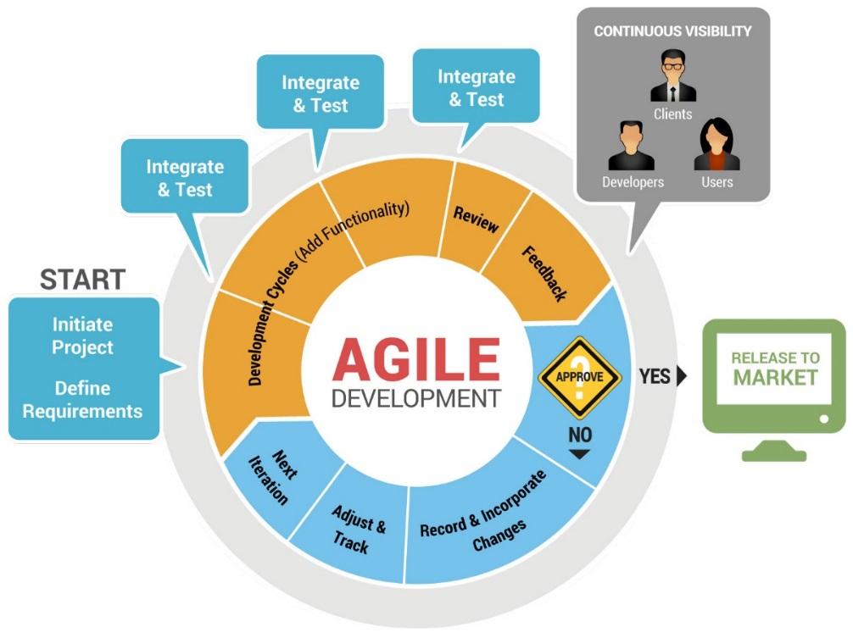  
Image 1.1 **Agile Methodology, source:** [**Code2u.net**](http://www.code2u.net/)

### Communication

Meetings will be done at least thrice a week. Updates, for daily scrum and weekly status reports are located in the [repository](https://code.google.com/p/apc-softdev-it111-05/w/list). For each iteration, the team will consider each sets of 3 weeks as a sprint. There will be 3 sprints in this term. The sprints will be aligned with each iteration that has been scheduled by the team’s *SOFTDEV* adviser.

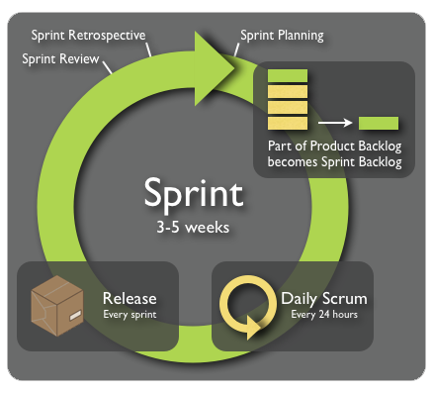  
Image 1.2 **Sprint, source:** [**Kaeru.se**](http://www.kaeru.se/scrum.png)

### Quality Assurance

From the above-mentioned methodology, the Quality Assurance Testing Phase will be following the same process of *Developing, Base-lining, and Testing*.

The processes of which were mentioned above happens each iteration / sprint. The steps inside each phase, involve the following:

* Research and Analysis
* Prototyping and Designing
* Testing and Planning

Various static tests and dynamic tests have been duly scheduled in line with the iterations. Naturally, the static testing schedules have been given priority over the succeeding dynamic tests.

The following image illustrates the proponents’ intended QAT Phase of the Project (which involves Testing, Quality Control and Quality Assurance):

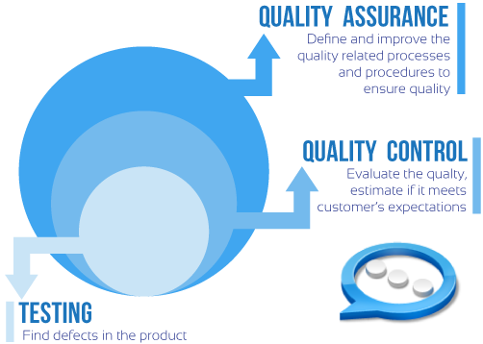

Image 1.3 **Testing, Quality Control and Quality Assurance,  
 source:** [**SystemsAppsControls.com**](http://systemsappscontrols.com/images/diagram.png)

## Feasibility standards

This sectionaddresses the issuesof *application complexity* as well as the anticipated *risks* in *schedule* and *operation* procedures*.* The following factors have been defined in order to verify the project’s feasibility. The table below illustrates these points and the team’s proposition for the development and quality assurance stages of the project.

|  |  |  |
| --- | --- | --- |
| Standard | Risks / Issues | Proposition |
| Application Complexity | * The various requirements included in the calendar warrants well – defined conditions and proper synergy between the database and the tool. * The integration of the tool to the site itself should also be considered of vital importance | * Proper standards in code development must first be defined, upon establishment of these defined standards, following it is key * The usage of the tools provided by our *adviser*, and a proper understanding of the MVC Framework is essential * Development procedures must be in line with the professional opinions of our *mentors* and *adviser* * For System Integration, it must be done in line with the system |
| Schedule Constraints | * The allotted timeframe for the project development and quality assurance phase is a maximum of 10 weeks. | * Development – wise, the tool’s functions must be assessed if the 10–week development process can accommodate the necessary changes and coding efforts by the team * In the Quality Assurance phase, the tool should be assessed by certain metrics and success factors to be defined in the latter part of this section * A schedule for both *SOFTDEV* and *QUALITY* has been given, and for the success of the development and testing phases, the team’s processes must be in line with this defined schedule |
| Client, User and Organizational Risks | * The risk of obtaining an error in logic in one year will mean an inheritance of the succeeding years’ errors * The risk of having to engage in maintenance and support for the application, after development | * Proper development of the product must be implemented. The client must verify the correctness of the data in the database of the proposed system, before the implementation phase * Plans for maintenance and support must be in place, even after implementation. This plan must be proposed to the client, along with the system |
| Operational Feasibility | * Risk of web - hosting and storing massive amounts of data in the database * Risk of user apathy and unresponsiveness from the target market | * Hosting the site, with large amounts of data may be mitigated by specifying early on with the client, the expected and the actual size of the data to be stored and used for the project * Through proper dissemination in local churches, and on the web – users may be properly oriented with the goal of the tool and the site itself |

Table 1.3 **Feasibility, Risk and Solution / Proposition Matrix**

# system recommendation

# The following recommendations are advised by the developers of the system:

# In accordance to the system itself, there will be various dependencies that may change in the course of the years, which is why the proponents of the project believe that the User Manual is of great importance. However, in certain circumstances wherein tweaking of code is necessary, the client may in turn hire / include other developers to use the code for the benefit of the Religious community.

# It is knowledgeable, that no system is error – free / bug – free. It has come to the knowledge of the developers, that in certain circumstances, there are various rules that are bent in the plotting of events within certain years, and this encompasses the logic created by the developers within the code, when this scenarios are encountered, we highly recommend the client to inform other developers, that they have hired that they may tweak the *yii* code, or the *calendar* codes, to be able to fix the said dates.

# target user beneficiaries

# The following are the beneficiaries of the fore-mentioned system developed by the ASND – LCMAM: LS team:

|  |  |
| --- | --- |
| Beneficiary | Benefits Received |
| Administrators | * Benefit of automatically – plotting dates in the database * Ease of editing for readings, links and optional readings * Simple administrator system and processes wherein admin can easily change / toggle items that are viewed in calendar |
| Priests, Lectors, Commentators | * Benefit of viewing the automatically – plotted readings for specific dates within the liturgical year * Benefit of listening to the audio files of the readings, set by the administrator for the readings of the said dates * Benefit of traversing through the different readings of every month within one liturgical year |

Table 1.4 **Beneficiaries and benefits Table**

# system failure

In any application, inherent latency issues, speed and reliability concerns will always be present. It is important to note that this application is not **error – free,** specifically due to the following:

* **System coding limitations** (Some factors that inhibit the developers from including multiple years in the calendar include the system slowing down and failing, upon requiring multiple events for all years, system is limited to only retrieving json data for it to display events, etc.)
* **Subjective event plotting** (Some events are specifically mandated by the Vatican or by the Pope, some are also left subjectively for the local priest / bishops to choose, therefore, this kind of subjectivity cannot be written in plain code (e.g. conflicts in solemnities and other same-leveled priority of events))
* **Multiple conditions to be considered** (There are some events that are dependent on other events for a certain year, that have not been identified, scheduled identification is only to be assessed during the year itself (e.g. new dates for Special Solemnities, etc.))
* There will always be **some variable and inconsistent date changes** in every liturgical cycle, meaning – not every date in the calendar might be populated for every year, and with due diligence of the developers, while in cooperation with the client, must be explained to the users of the system

# system functions

# The following are the functions of the system:

* 1. **Security of User Registration and Login (Registration and Login)**
     1. User Site Access
     2. User Site Registration
     3. User Site Login
  2. **Display of calendar events (Event view)**
     1. Calendar Display
     2. Event Display
        1. Event Hover
        2. Event Popup
     3. Event Readability
  3. **Event Rendering in the calendar (Event Plotting)**
     1. Moveable Feasts
        1. Ash Wednesday
        2. Easter Sunday
        3. Pentecost Sunday
        4. First Sunday of Advent
     2. Months
        1. January – December
  4. **Administrator Privileges (CRUD)\***

*It is important to note, that not all items have CRUD functionalities, this will be explained in detailed in the Features not to be tested

* + 1. Create Items
    2. Read Items
    3. Update Items
    4. Delete Items

# system design and diagrams

# The following are the advisers of the fore-mentioned students for the ASND – LCMAM: LS team:

# iterations

# Each of the mentioned iterations below were the scheduled sprints for the team. The following iterations include the schedule designated for each iteration. For more information, you may visit the SOFTDEV wiki site of the proponents, which is referenced below (with the link), in the Hyperlinks and References section

# Iteration 1 – March 11, 2015, Asia Pacific College, 1:30 – 2:30

# Iteration 2 – April 1, 2015, Asia Pacific College, 1:30 – 4:30

# Iteration 3 – April 17, 2015, Asia Pacific College, TBA

# source code

# The source code is located in the [*asnd_lcmam application*](https://github.com/joegeneq/apc-softdev-it111-05/tree/master/application/asnd_lcmam) folder in the Google Code repository. (You may click the link to be redirected to the source codes used by the proponents)

# hyperlinks and references

The following table summarizes the documents / repositories referenced in this document.

|  |  |  |
| --- | --- | --- |
| **Document Name and Version** | **Description** | **Location** |
| **ALS Google Code Repo** | AngSalitaNgDiyos.com Liturgical Site – Repository (Wiki) | [Google Code Repository](https://code.google.com/p/apc-softdev-it111-05/source/browse/#git%2Fdocumentation%2Fquality) |
| **ALS Github Repo** | AngSalitaNgDiyos.com Liturgical Site – Repository | [Github Repository](https://github.com/joegeneq/apc-softdev-it111-05) |
| **ALS Quality Wiki** | AngSalitaNgDiyos.com Quality Assurance Wiki Site | [QUALITY Wiki](http://projects2.apc.edu.ph/wiki/index.php/QUALITY_IT111_AngSalitaNgDiyos.com_Liturgical_Site_-_SQAP) |
| **ALS Softdev Wiki** | AngSalitaNgDiyos.com Software Development Wiki Site | [SOFTDEV Wiki](http://projects2.apc.edu.ph/wiki/index.php/SOFTDEV_IT111_Group_05_Lectors_and_Commentators_Ministry_for_the_Archdiocese_of_Manila_-_Angsalitangdiyos.com) |
| **CDC UP Test Case Template** | Centers for Disease Control and Prevention UP Test Case Template | [CDC UP Test Case Template](https://www.google.com.ph/url?sa=t&rct=j&q=&esrc=s&source=web&cd=5&cad=rja&uact=8&ved=0CCoQFjAE&url=http%3A%2F%2Fwww2.cdc.gov%2Fcdcup%2Flibrary%2Ftemplates%2Fcdc_up_test_case_template.doc&ei=0pT5VKCdIKHGmQXVpoC4CQ&usg=AFQjCNHRcmh-4F4pWH0W1gslKV60qkpIoA&sig2=Tm19bViOMQo17bwDv4Y9yg&bvm=bv.87611401,d.dGY) |

# user manual

# The user manual is also available in this link: User Manual.

# name of team members and duties

# The following are the responsibilities of each team member, alongside their role in the development and design process of the team:

|  |  |  |
| --- | --- | --- |
| Name | Roles | Responsibilities |
| Joshua C. Dimapilis | Project Manager / Developer | * Overseeing of the Project Status and Progression * Management and leadership of the Project team * Planning and Evaluation of Development and Quality Assurance |
| Kimberly Mae B. Elizondo | Quality Assurance Tester / Developer | * Quality Assurance Consulting * Monitoring of schedule, iterations and sprints * Business Requirements Analysis |
| Trixia Marie A. Urquiza | Quality Assurance Tester / Developer | * Database Design and Management Consulting * Approval of Change Requests and adjustments * Management of   documentation and scrum |